Request for School Psychological Services and Support
Name:
Date:
Name of student of concern (if applicable):
Person making this request:

Please complete the information up to the dotted line and return to the school psychologist.
My concerns primarily address the following issues. Check all that apply
- Inadequate academic progress | - Mental Health and Wellness
- Comprehension and/or language concerns | - Social/interpersonal interactions
- Attendance | - Behavior concerns
- Failing Grades or Incomplete Assignments | - School or student safety**
- IEP Progress | - Attention concerns
- Other: | - Disengagement from school/class/peers
**NOTE: These need to be assessed immediately. Please discuss with the School Principal if School Psychologist is not immediately available.
Briefly describe the problem/issue:

Type of Request:
- Assess the Issue: I would like the SP to investigate the problem and help me determine the appropriate course of action or needs.
- Consultation: I would like to talk with the SP about the problem and get some suggestions for ways that I could intervene.
- Collaboration: I would like the SP to work together with a team of people to respond.
- Intervention: I would like the SP to provide direct intervention support to address the problem.
Preferred method of communication/follow up?
- Email. Email Address? ___________________________________________________________
- Phone Call. Number? ____________________________________________________________
- Face to Face Meeting: Possible Dates & Times to Meet? ________________________________
Follow Up Date: ______________________ Follow Up Notes:What are your goals for the student?
Mark the domains of the Practice Model What services are you going to provide (frequency, intensity, duration)?
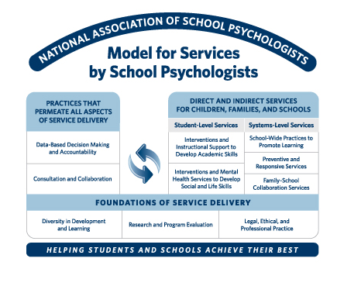that reflect the services provided:

